API Testing (Tests were done before and after the code changes)
Installation:
Was not able to use Docker here, have installed Rancher desktop (v1.22.0) along with Kubernetes (v 1.34.6) with able to have Claims API in good running condition.
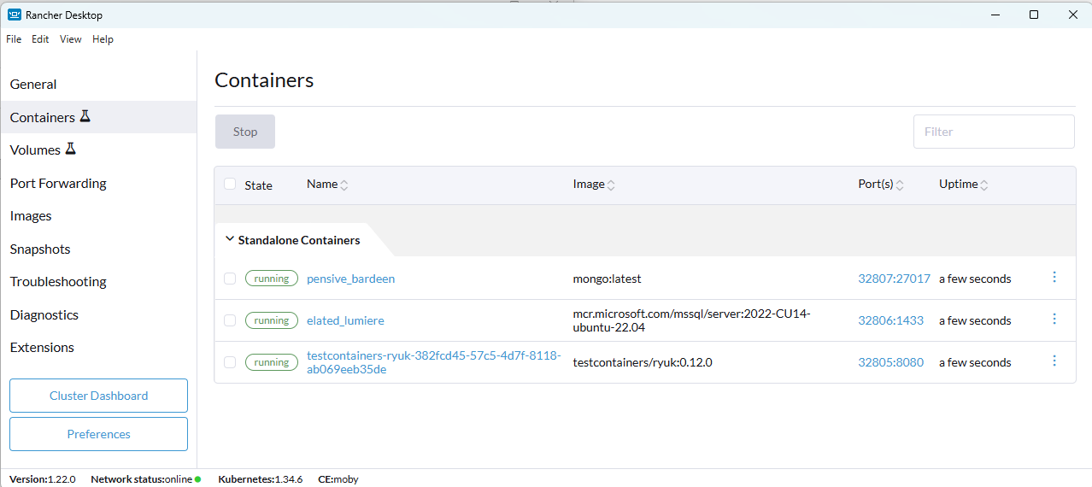
Swagger:
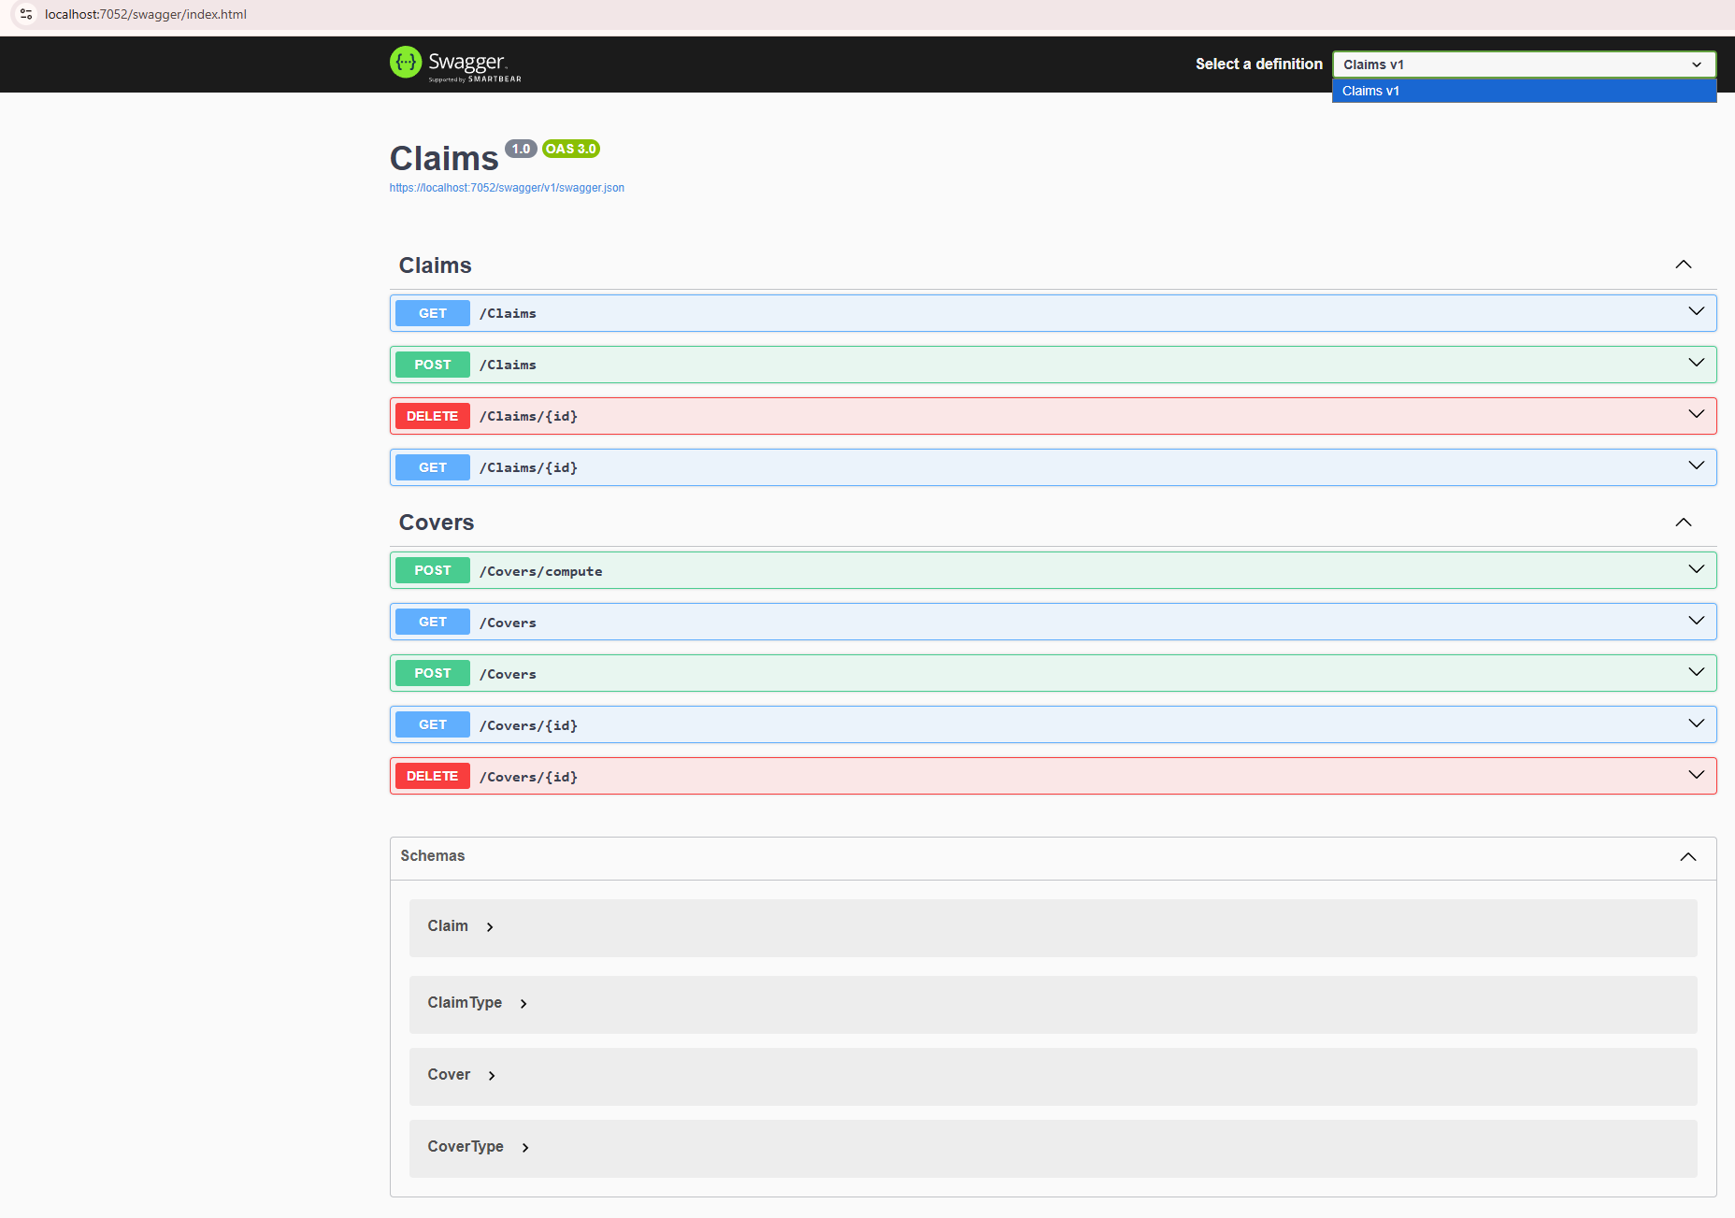
Test Cases:
Test Samples of each of the methods below in Claims API
Post / Covers (Insert)
Input JSON Samples:
{
"id": "Cover-1",
"startDate": "2026-05-21T00:00:00Z",
"endDate": "2026-12-31T00:00:00Z",
"type": "Yacht",
"premium": 0
}

{
"id": "Cover-2",
"startDate": "2026-05-21T00:00:00Z",
"endDate": "2026-12-31T00:00:00Z",
"type": "PassengerShip",
"premium": 0
}

{
"id": "Cover-3",
"startDate": "2026-05-21T00:00:00Z",
"endDate": "2026-12-31T00:00:00Z",
"type": "Tanker",
"premium": 10
}

Cover-1

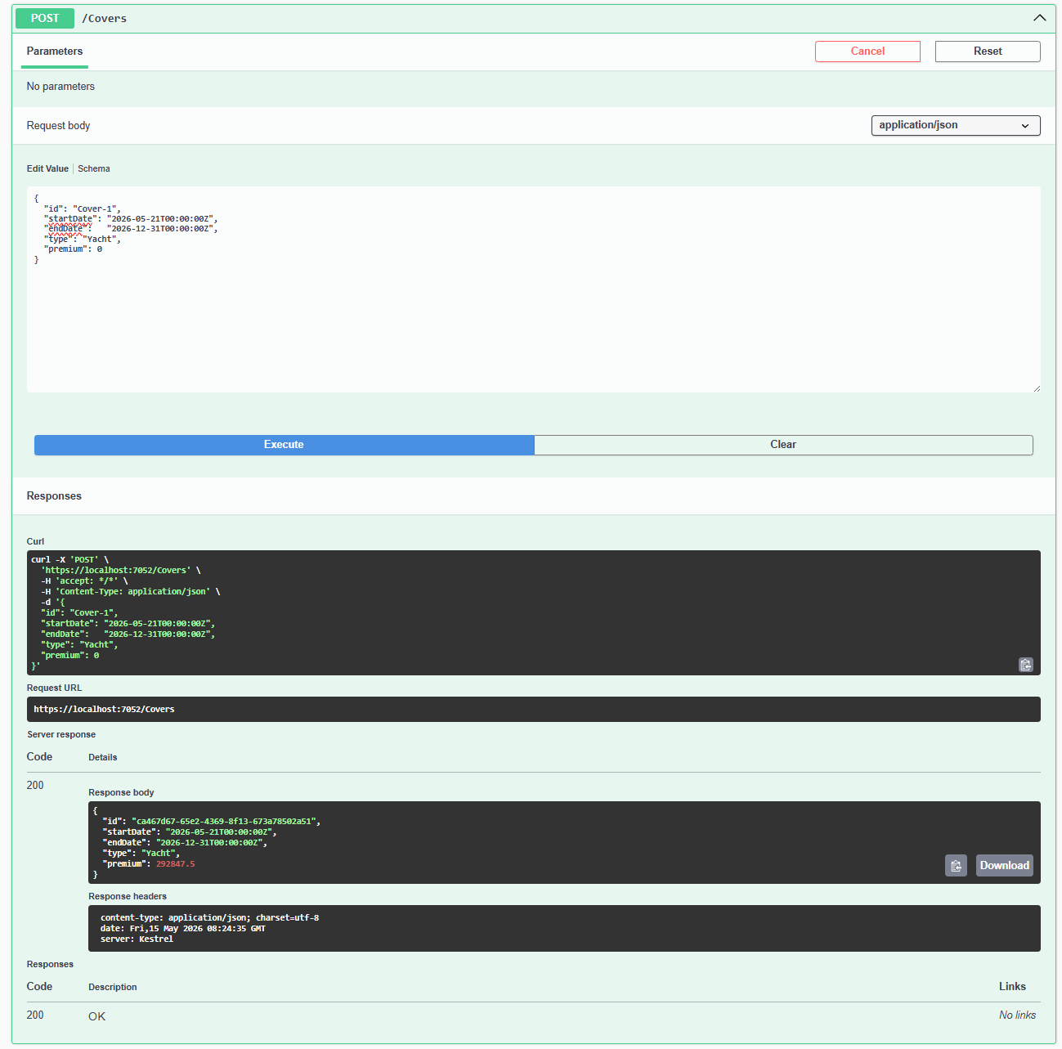
Response JSON for Cover 1
{
"id": "ca467d67-65e2-4369-8f13-673a78502a51",
"startDate": "2026-05-21T00:00:00Z",
"endDate": "2026-12-31T00:00:00Z",
"type": "Yacht",
"premium": 292847.5
}

Cover-2
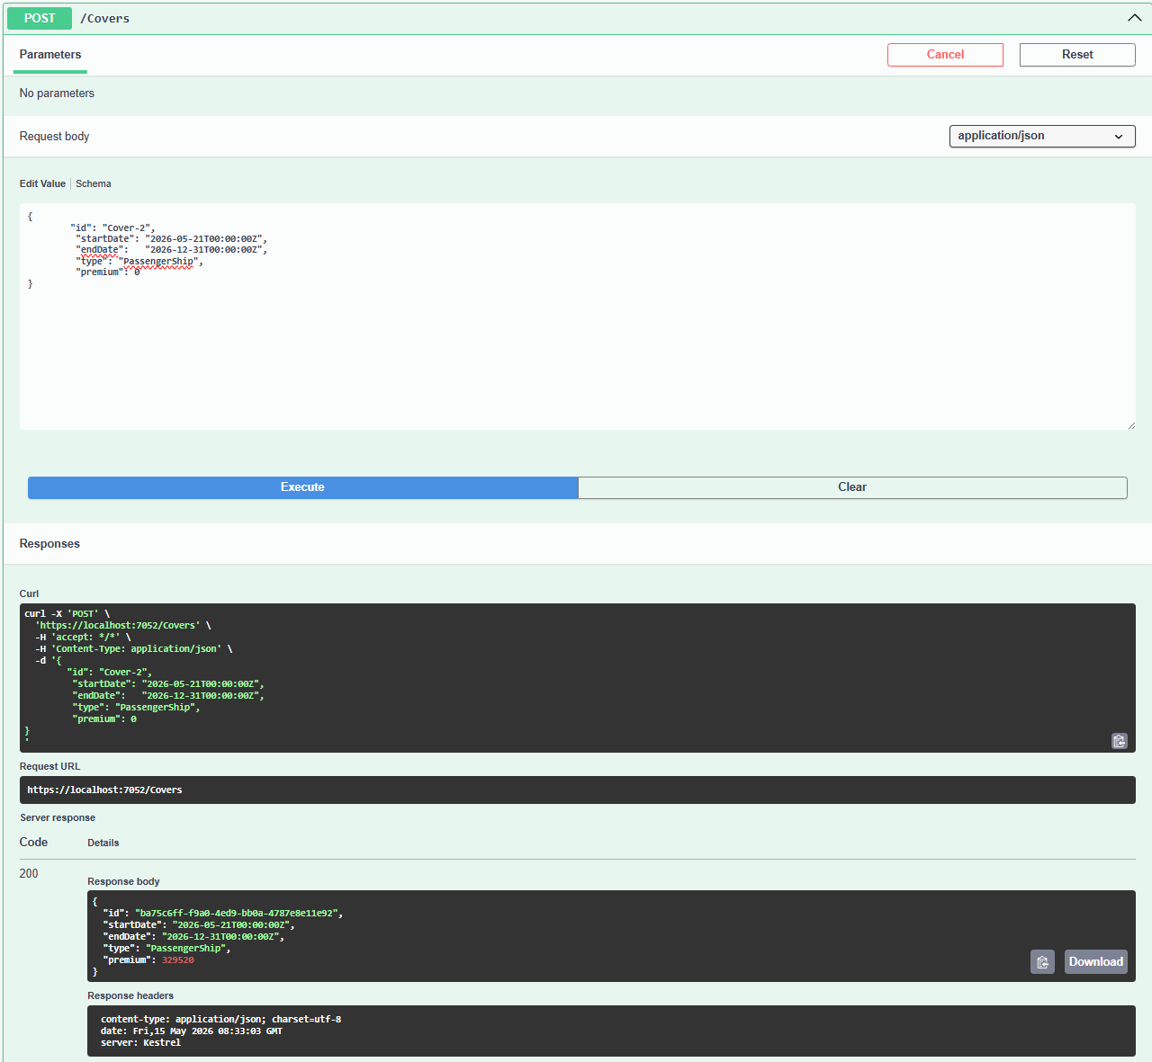

Response JSON for Cover 2:
{
"id": "ba75c6ff-f9a0-4ed9-bb0a-4787e8e11e92",
"startDate": "2026-05-21T00:00:00Z",
"endDate": "2026-12-31T00:00:00Z",
"type": "PassengerShip",
"premium": 329520
}

Cover-3
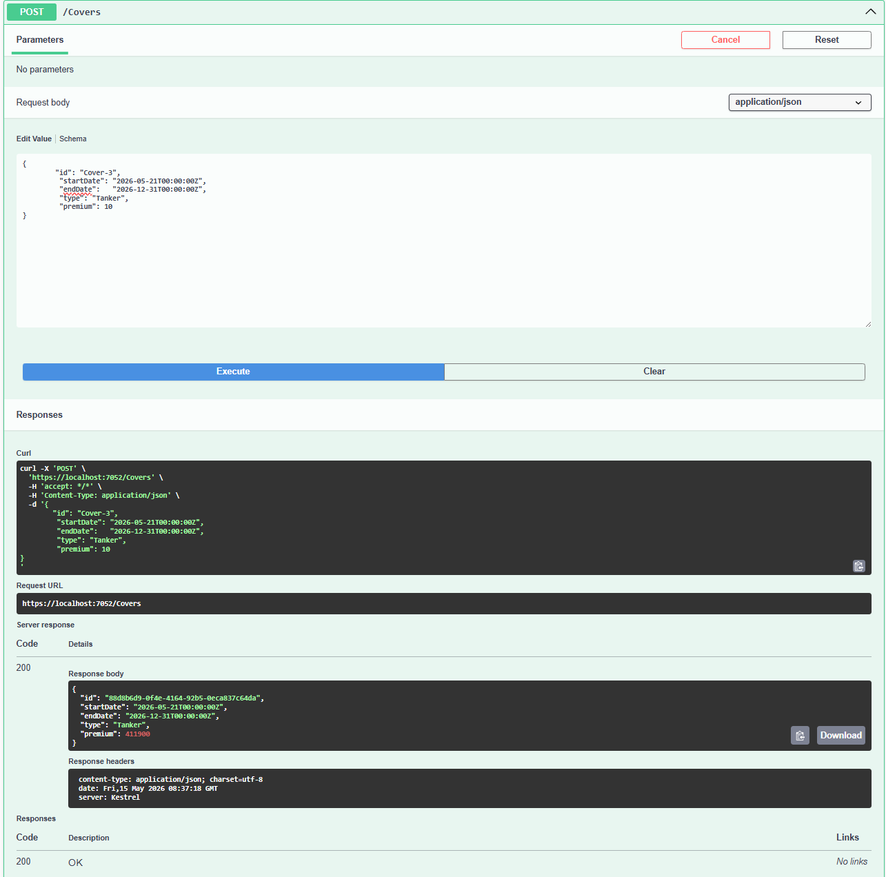
Response JSON
{
"id": "88d8b6d9-0f4e-4164-92b5-0eca837c64da",
"startDate": "2026-05-21T00:00:00Z",
"endDate": "2026-12-31T00:00:00Z",
"type": "Tanker",
"premium": 411900
}

Get /Covers
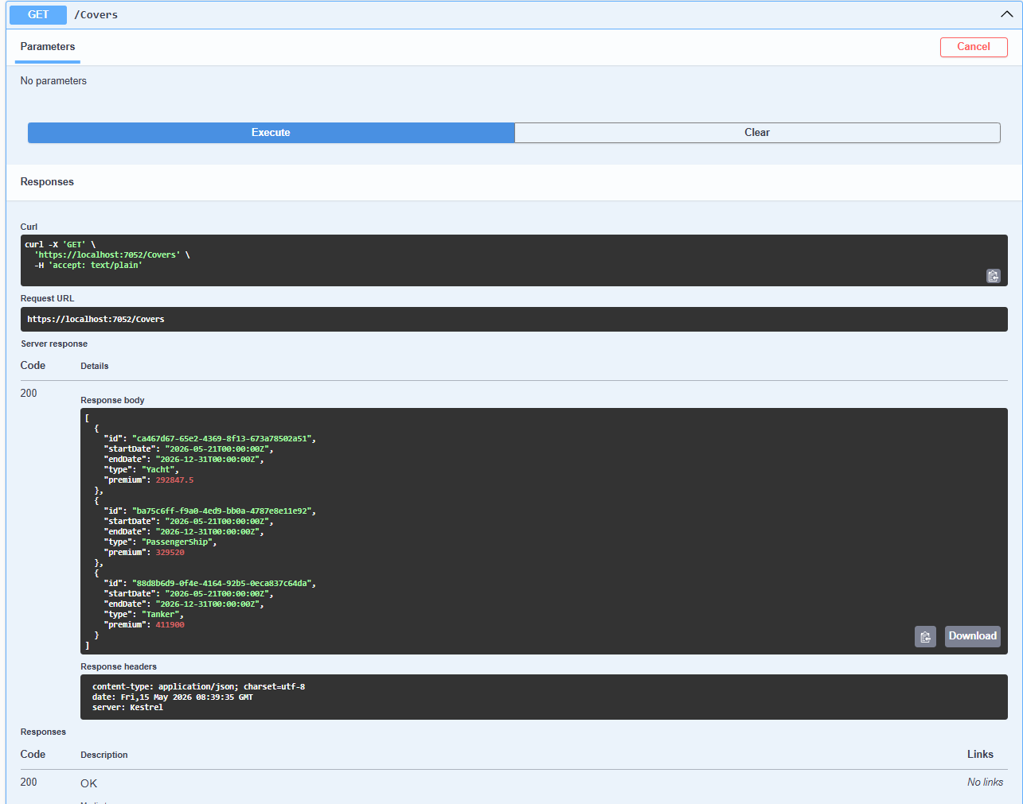

Get /Covers {id}
Request and Response
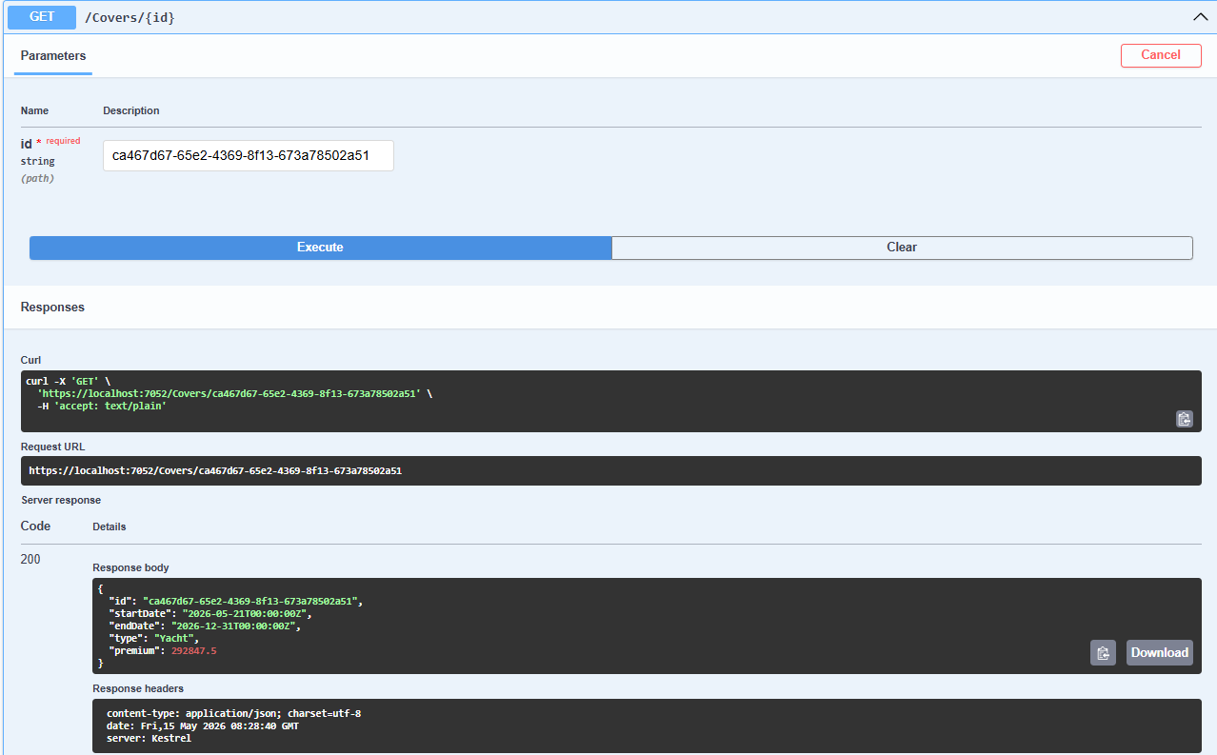

Claims
Post /Claims
Claim-1
{
"id": "Claim-1",
"coverId": "ca467d67-65e2-4369-8f13-673a78502a51",
"created": "2026-05-22T08:31:30.038Z",
"name": "string",
"type": "Collision",
"damageCost": 0
}
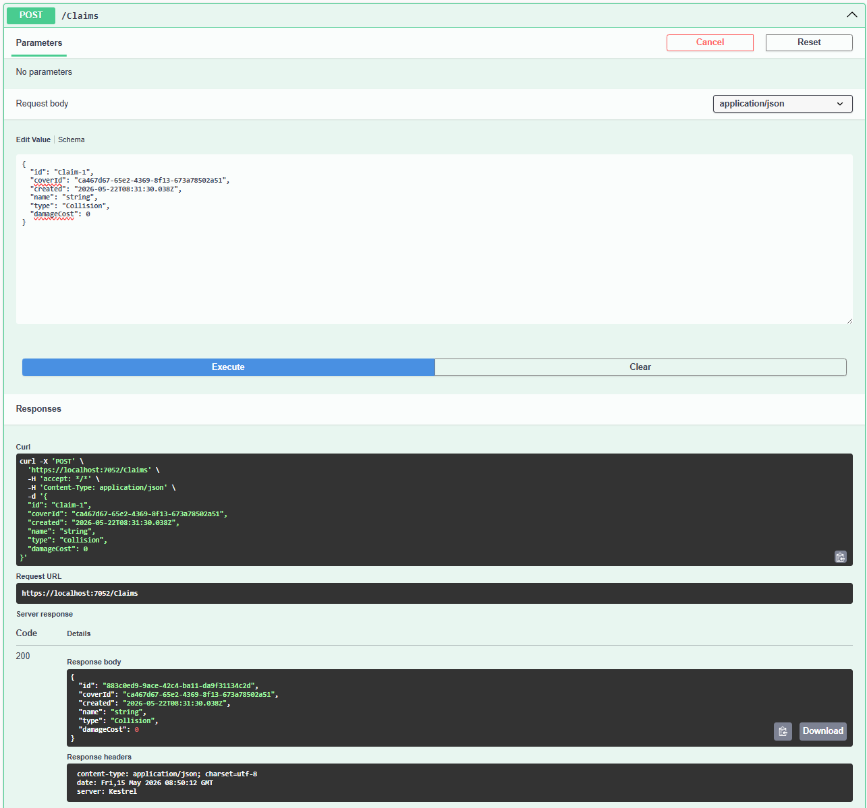
Response for Claim 1
{
"id": "883c0ed9-9ace-42c4-ba11-da9f31134c2d",
"coverId": "ca467d67-65e2-4369-8f13-673a78502a51",
"created": "2026-05-22T08:31:30.038Z",
"name": "string",
"type": "Collision",
"damageCost": 0
}
Claim-2
{
"id": "Claim-2",
"coverId": "ba75c6ff-f9a0-4ed9-bb0a-4787e8e11e92",
"created": "2026-05-23T08:31:30.038Z",
"name": "string",
"type": "Grounding",
"damageCost": 0
}
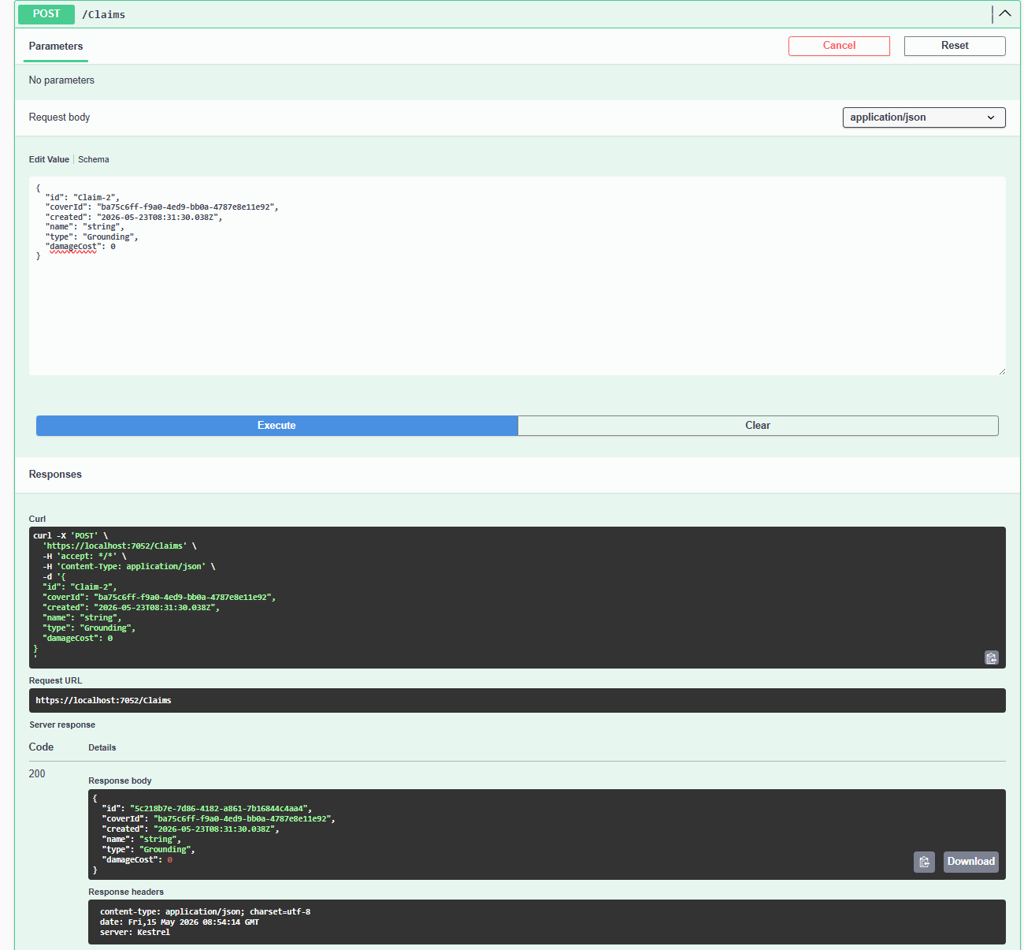
Response for Claim 2
{
"id": "5c218b7e-7d86-4182-a861-7b16844c4aa4",
"coverId": "ba75c6ff-f9a0-4ed9-bb0a-4787e8e11e92",
"created": "2026-05-23T08:31:30.038Z",
"name": "string",
"type": "Grounding",
"damageCost": 0
}
Claim-3
{
"id": "Claim-3",
"coverId": "88d8b6d9-0f4e-4164-92b5-0eca837c64da",
"created": "2026-05-24T08:31:30.038Z",
"name": "Claim-3",
"type": "BadWeather",
"damageCost": 0
}
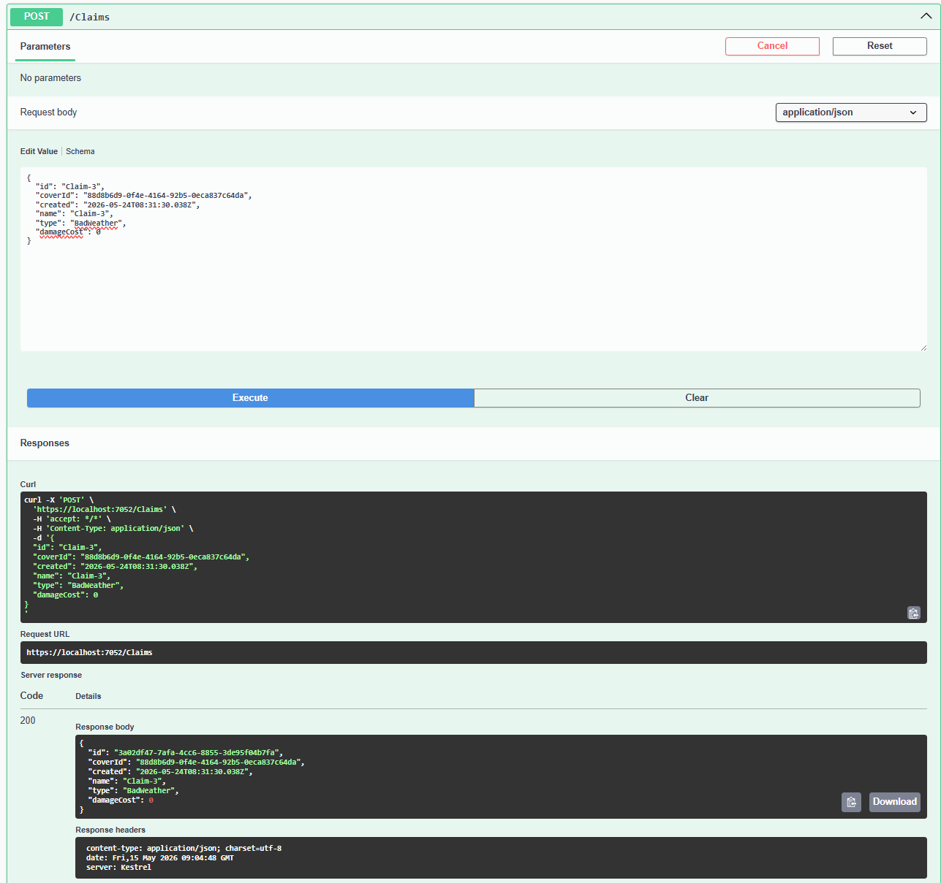
Response for Claim 3
{
"id": "3a02df47-7afa-4cc6-8855-3de95f04b7fa",
"coverId": "88d8b6d9-0f4e-4164-92b5-0eca837c64da",
"created": "2026-05-24T08:31:30.038Z",
"name": "Claim-3",
"type": "BadWeather",
"damageCost": 0
}
Get /Claims
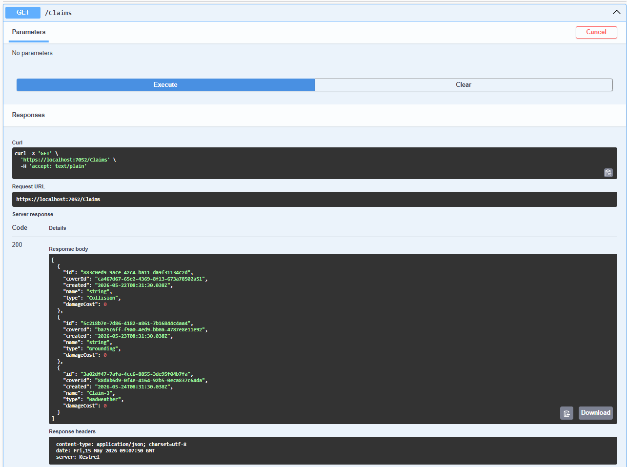

Post /Covers/Compute
CoverType: PassengerShip (3 scenarios)
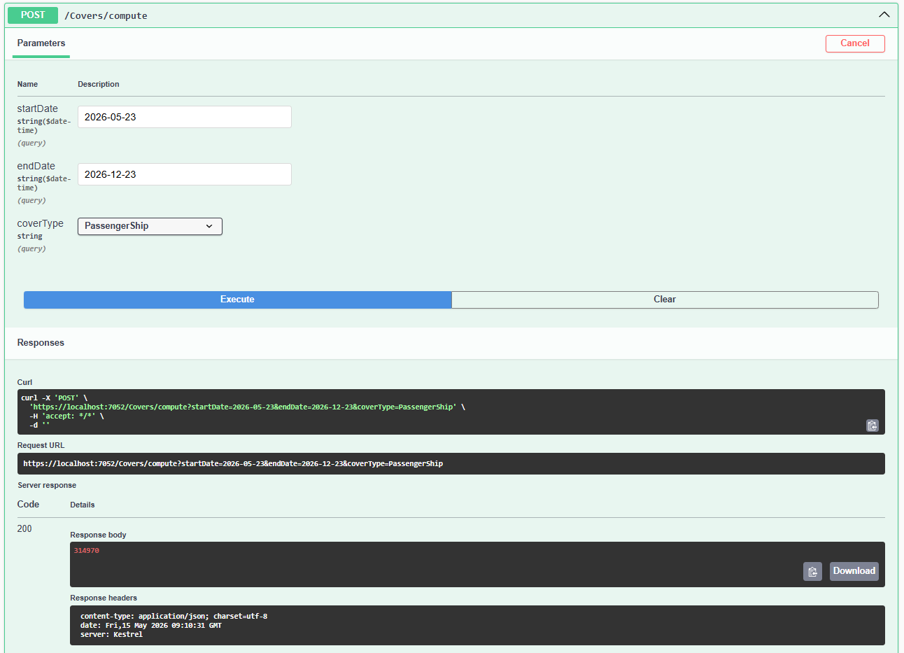
Response: 314970
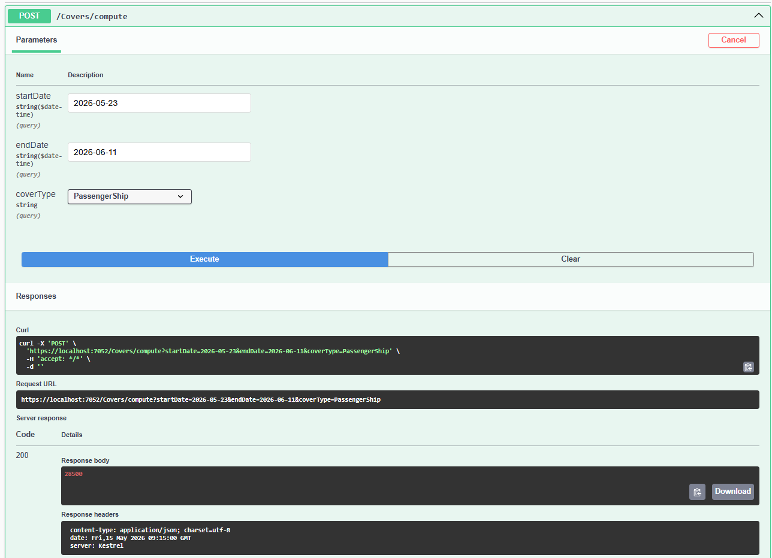
Response:28500
Total Days = between 11-06-2026 and 23-05-2026 = 19 days
Base Daily Rate = 1250
Calculation = 19 * 1250 * 1.2m (20% expensive for PassengerShip)
+ 0 mid period days + 0 last days = 28500
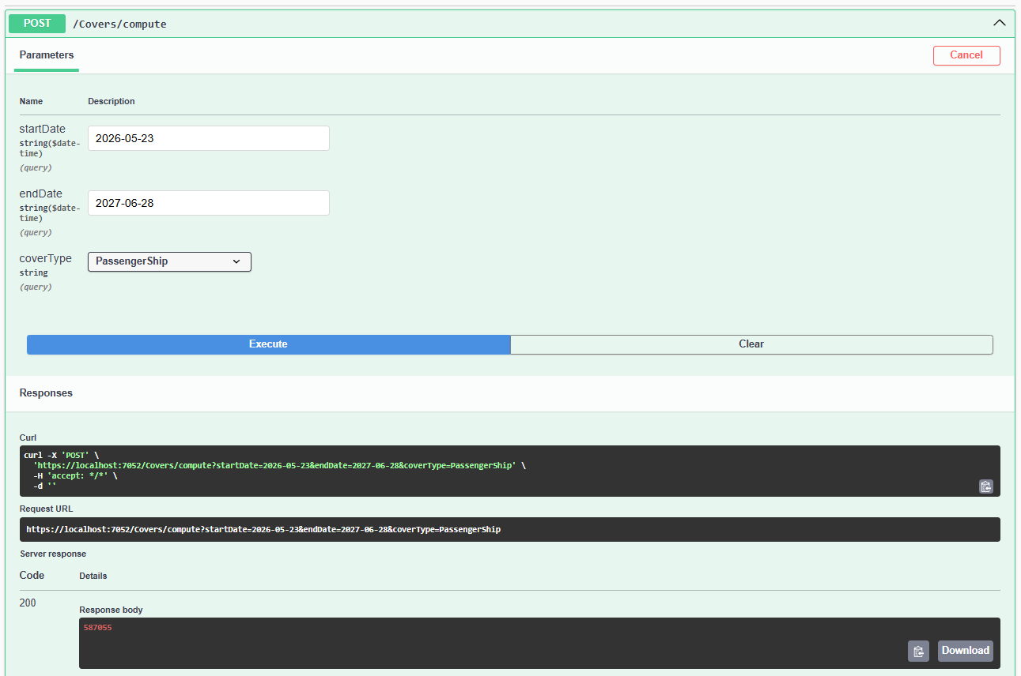
Response: 587055

CoverType: Yacht
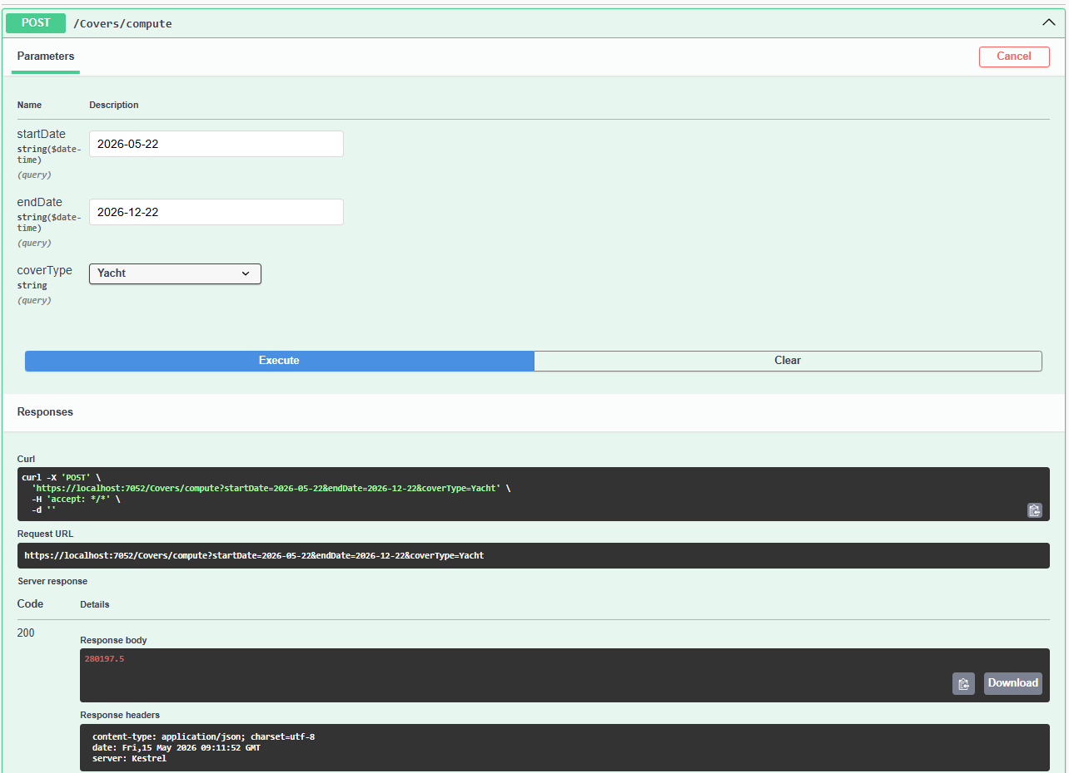
Response: 280197.5

Tanker
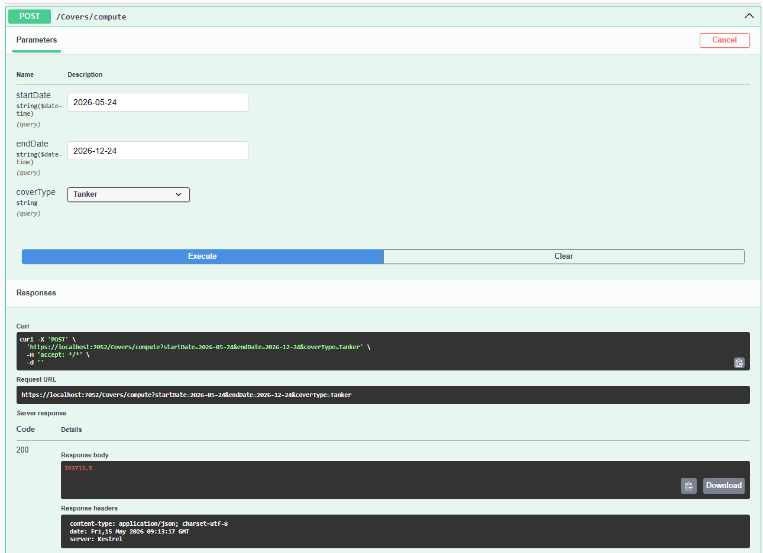
Response: 393712.5

Delete
Delete /Claims/ {id}
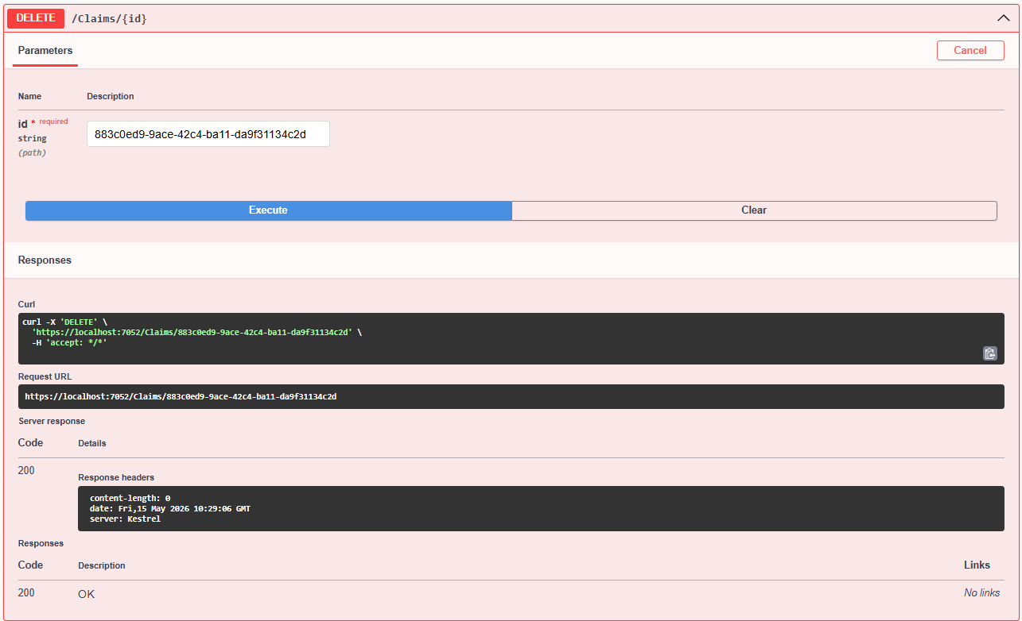
Delete /Covers/ {id}
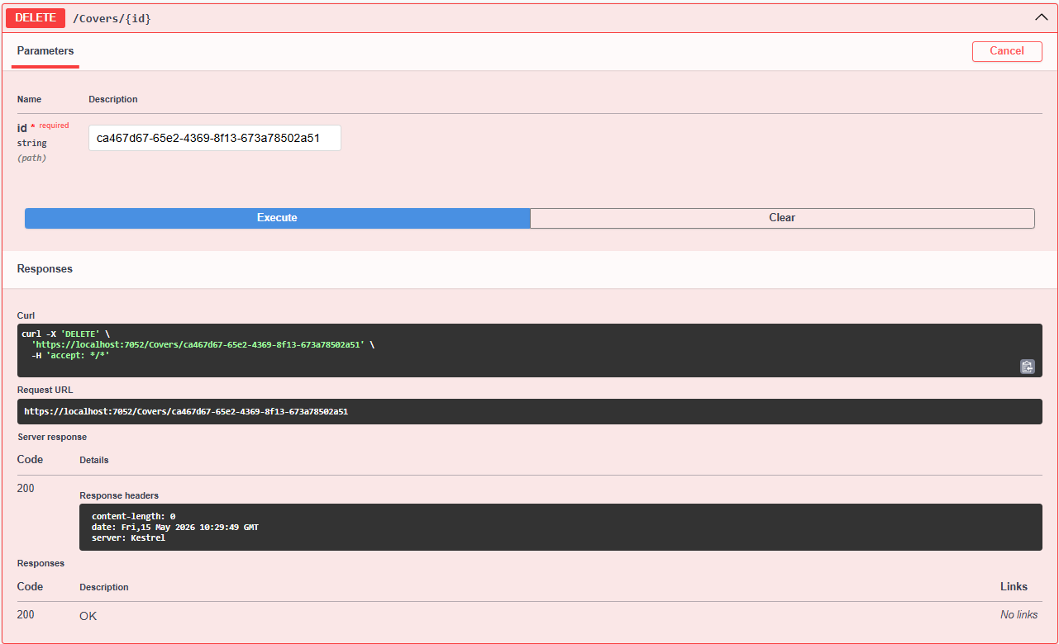
Negative Test Cases:
Post /Cover
Start Date less than Today’s Date:
